Homechoice Login Reset guidance

- If you are unable to login to your Homechoice account because you have forgotten your UNIQUE REFERENCE NUMBER, please select ‘I have forgotten my login reference’ here:

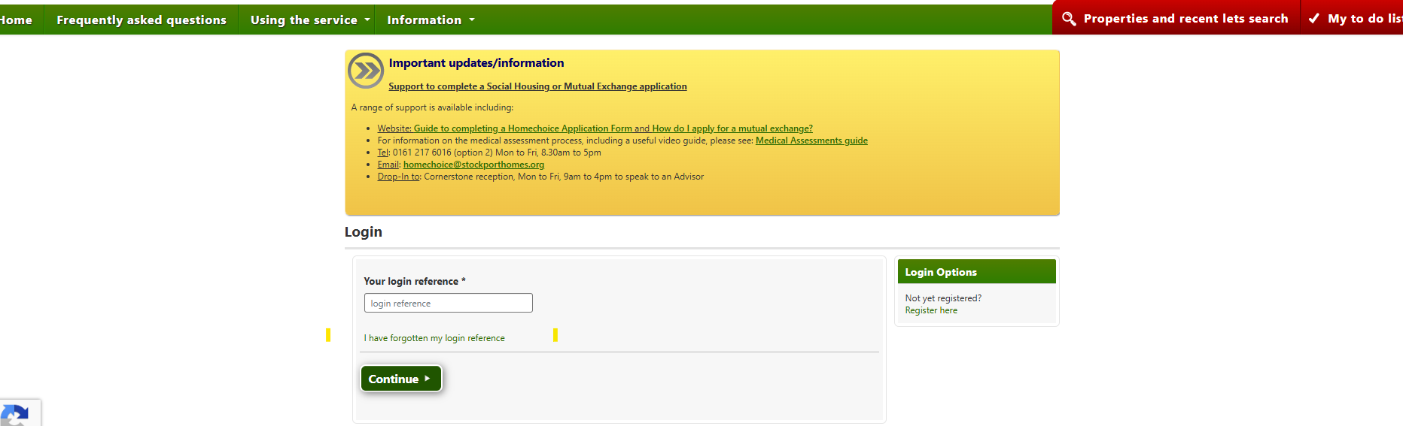

- Enter the email address you used to set up your Homechoice account here:

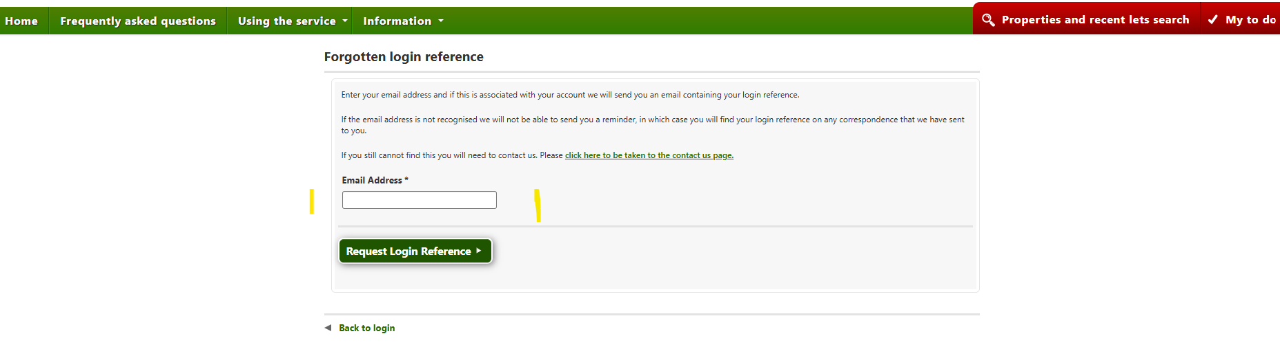

- You will receive the following email from donotreply@homechoicestockport.org :

Dear [customer name],
As requested here is a reminder of your Login Reference: [ref number]
You can use this to log into our website at https://www.homechoicestockport.org/
Please contact us if you need any more assistance.
You received this email because someone entered the email address '[customer email address]’ in the Forgotten Login Reference part of our website. If this was not you then please ignore this email.
- Proceed to the Login page and use the confirmed [ref number]

- If you have forgotten your MEMORABLE DATE / PASSWORD, please select ‘I have forgotten my password’ on the screen below:

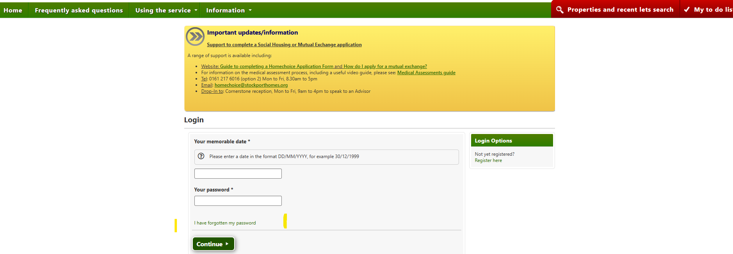

- Complete the details in the screen below and select ‘Reset’:

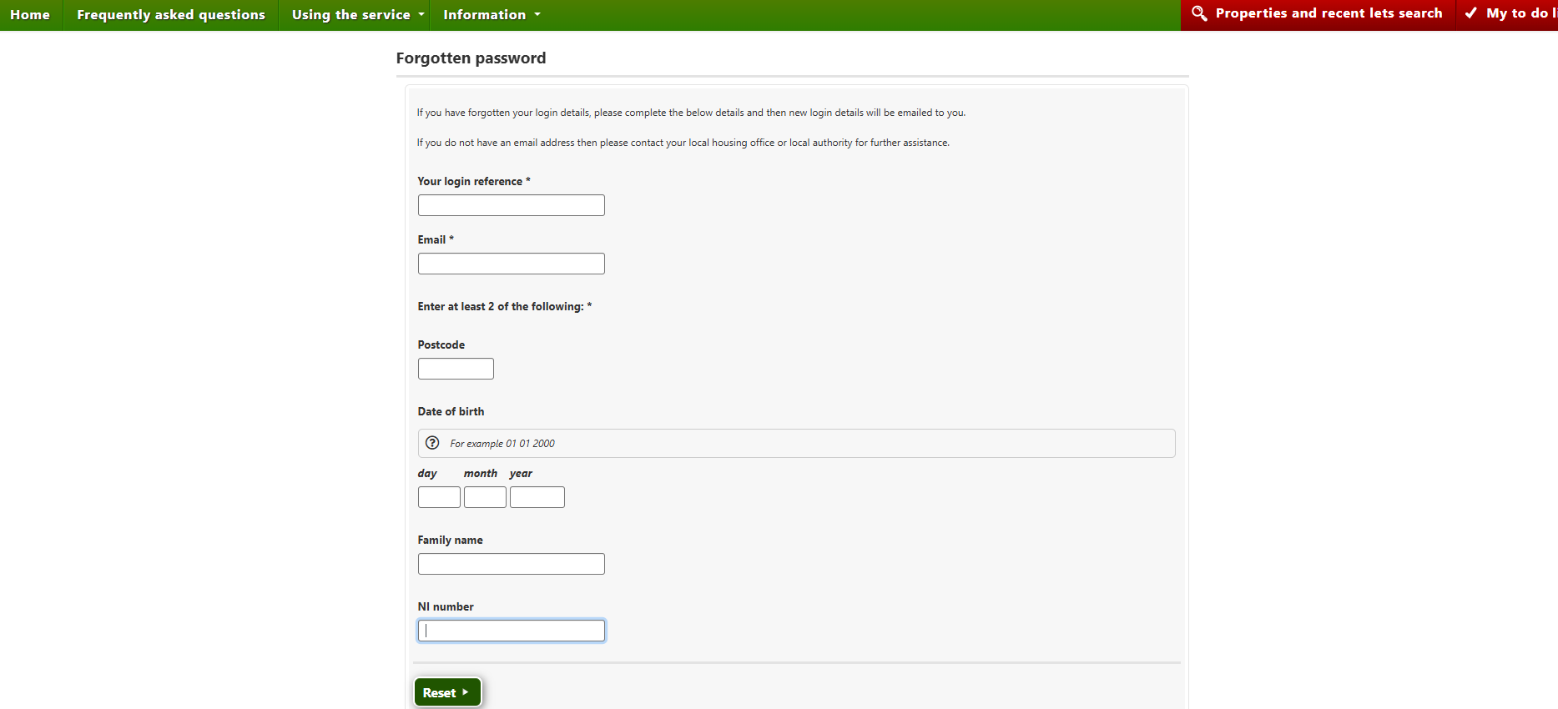

- The following message will appear on your screen confirming your details have been reset and emailed to you:

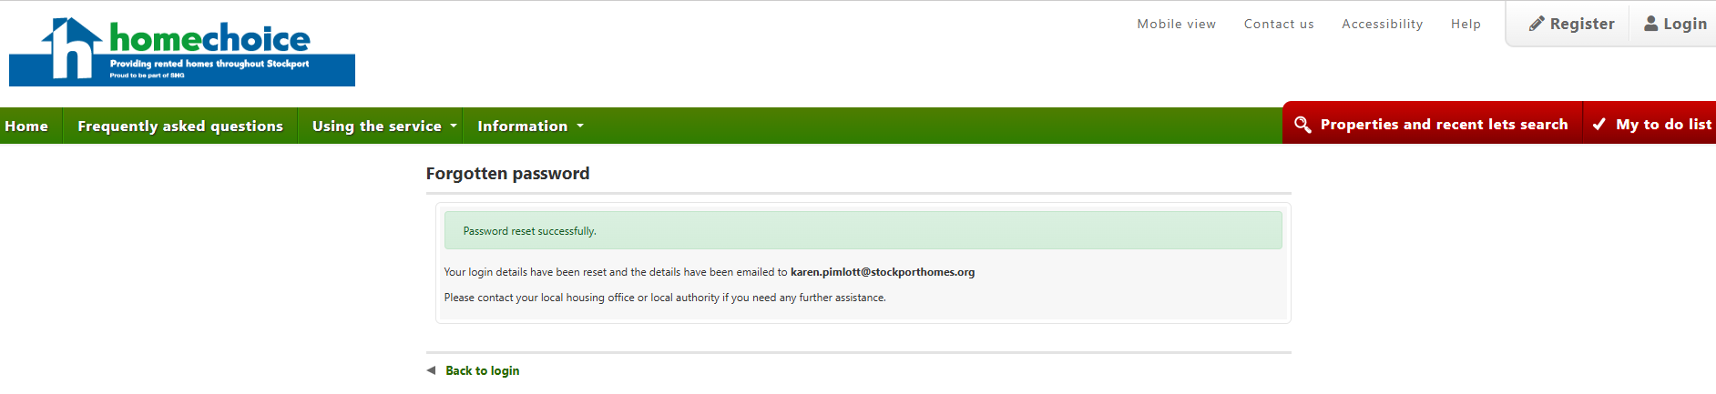

- You will receive the following email from donotreply@homechoicestockport.org

Dear [customer name],
Your memorable date has been reset to [new memorable date]
Your password has been reset to [new password]
Visit http://www.homechoicestockport.org to login.
Please contact your local housing office or local authority if you need any further
assistance.

